Albacore Canadian National
Championships
September 15 - 17, 2023
ORGANIZING AUTHORITY: CANADIAN
ALBACORE ASSOCIATION
In cooperation with the Thornbury Yacht Club
Official Website:https://albacore.ca

AMENDMENT # 1

SUPPLEMENT to the STANDARD SAILING INSTRUCTIONS (SSI)
(Numbering corresponds to the RRS Appendix S)

Delete SSI 5.3 and replace with:

5.3 The schedule of races is as follows.
Date | Races / day
September 15, 2023 | Up to 4 races scheduled | First signal at 12:00 pm
September 16, 2023 | Up to 4 races scheduled | First signal at 11:00 am
September 17, 2023 | Up to 4 races scheduled | First signal at 10:00 am

Add SSI 13.6 and 13.7:

13.6 Appendix P, Special Procedures for Rule 42, shall apply and is amended as follows: P2.3 is deleted, P2.2 will apply to the second and subsequent penalties.
13.7 Jury vessels may be positioned anywhere on the course area. Their position at any time will not be grounds for a request for redress. This changes RRS 60.1(b).

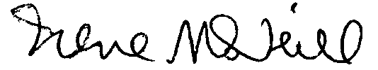

Irene McNeill
Principal Race Officer
September 8, 2023

